Moracchini
CSD402-308A(2265-DD)
Mar 15, 2026

Java and JavaFX installation
Module 11.3 Assignment
Pr. Payne

Screenshot 1: Java runtime installation

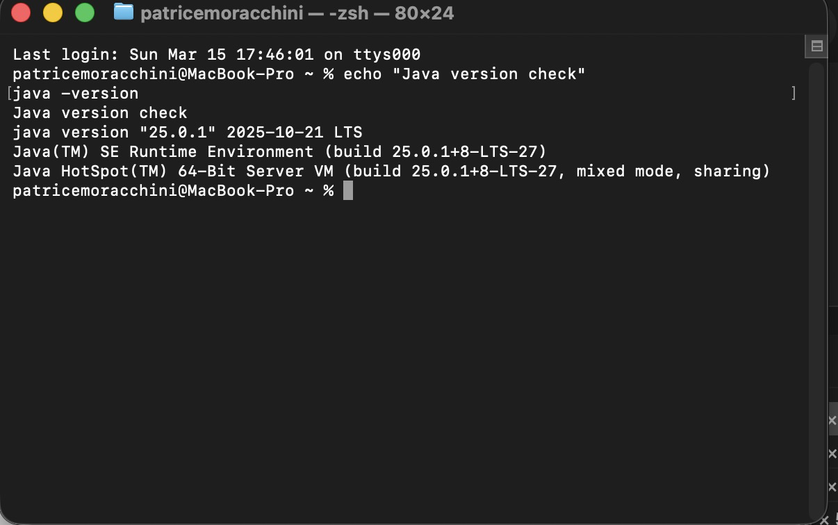

Screenshot 2: Java compiler installation

[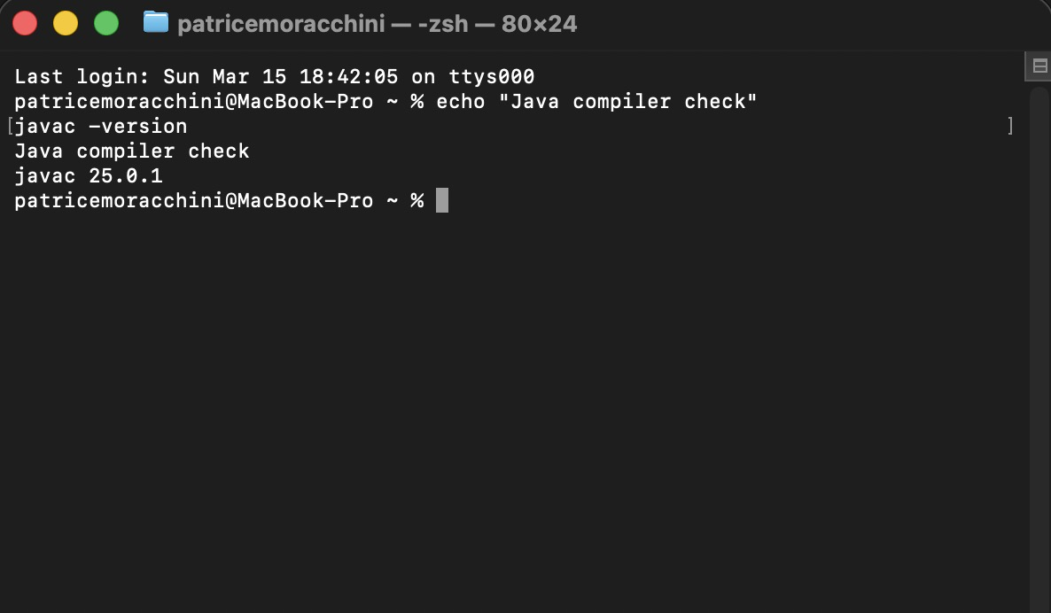]

Screenshot 3: Java path configuration

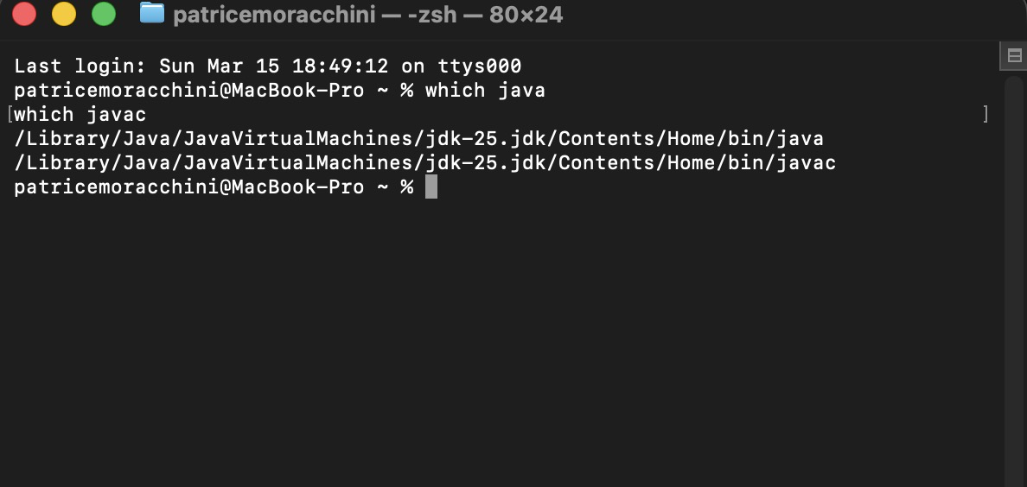

Screenshot 4: JavaFX SDK library files

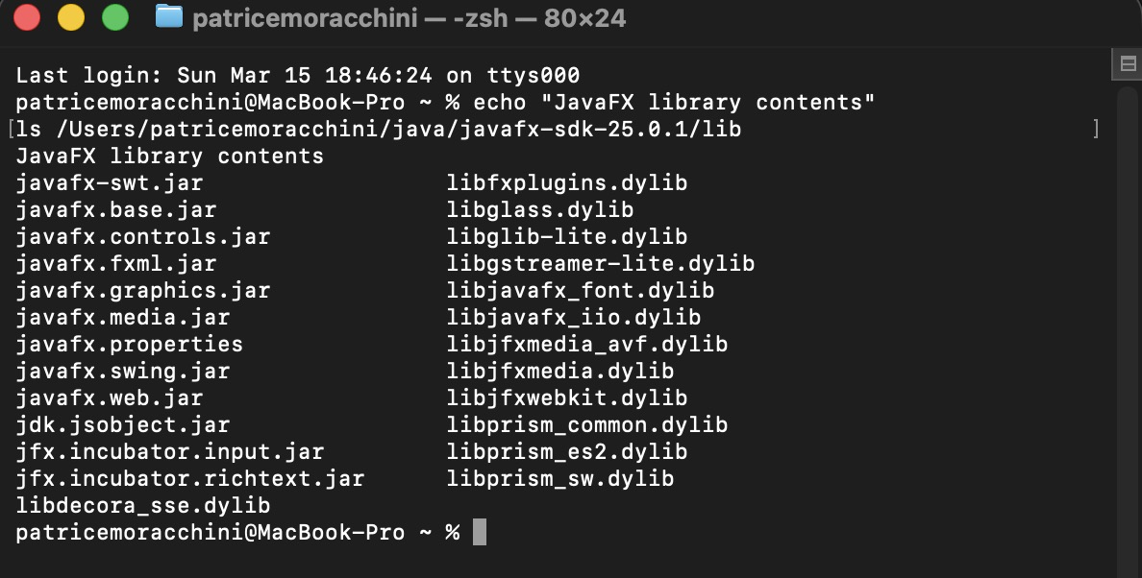

Screenshot 5: JavaFX compilation

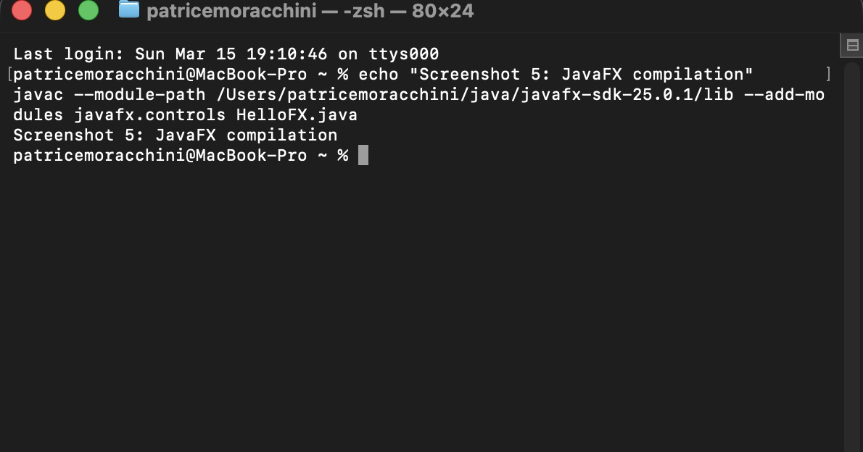

Screenshot 6: JavaFX application running

